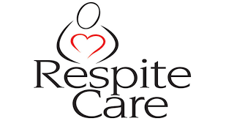
Provider
Satisfaction Survey

Thank you for taking the time to complete the survey below. The questions should take no more than 5 minutes, but will provide us with valuable information to enhance our program! Once completed, please e-mail the survey to Britt.Feldman@navy.mil.

On a Scale of 1-5

1=strongly disagree 2=disagree 3=neutral 4=agree 5=strongly agree NA=Not Applicable

Please rate the following:

- Did you have clear communication and instruction with the Fleet and Family Support Center case manager to help you provide services?

- Rate your overall experience with the family you provided Urgent Respite Care for?

- Were the instructions for filing out the invoice and voucher clear and understandable?

- Rate your overall experience with your Fleet and Family Support Center case manager?

- Were you reimbursed quickly for the services you provided?

- Would you continue to provide Urgent Respite Care services, in collaboration the Fleet and Family Support Center, to other families?

Please list any additional feedback you would like to share in the space below!

Thank you again for completing the survey!

If you would like to speak to someone further about your Urgent Respite care experience please contact Britt Feldman at britt.feldman@navy.mil, 360-315-5170.

